The Scramble for Africa
SCRAMBLE CARTOON
Answer the following questions based on the Scramble for Africa cartoon
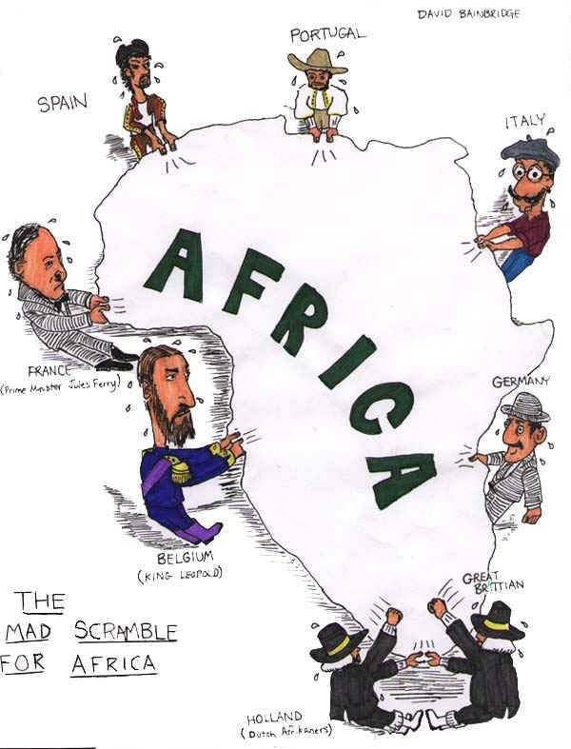
1. According to the cartoon, which European countries were fighting for a position in Africa?
2. How did the Berlin Conference lead to the situation shown in this cartoon?

AFRICA MAP COMPARISON
Examine the Maps below. Then answer the questions that follow
MAP 1
MAP 2
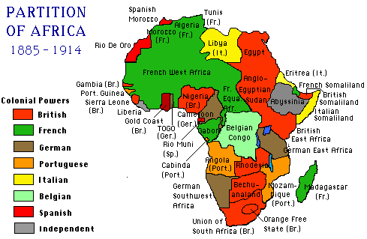
above maps from http://fresno.k12.ca.us/schools/s090/lloyd/imperialism.htm
1. What is the main difference between the 2 maps?
2. What part did the Berlin Conference play in the creation MAP 2?
3. What happened to the native African political entities by 1914?
4. According to Map 2-- Which 2 European countries held the most territory in Africa?
AFRICA POLITICAL DIVISIONS IN 1913
Percentage of Africa Controlled by European Countries in 1913
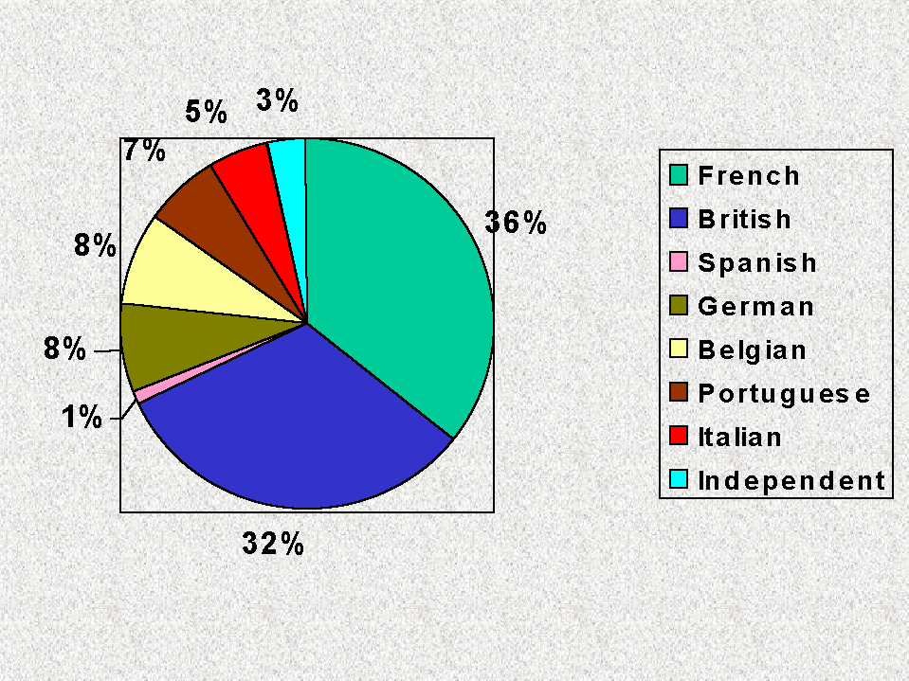
data above compiled from Modern World History: Patterns of Interaction , 1999 by McDougal Littell, page 308
Answer the following questions based on the chart above
1. What percentage of Africa was colonized by 1913?
2. According to the graph, Which 2 European countries held the most territory in Africa? (did you get the same answer as #4 in the Map Comparison above?)
3. What percentage Africa was controlled by the rest of the countries (excluding the 2 countries mentioned in #2)?
4. Think about it: Would the information in MAP 2 and the pie chart above be the same if there had never been a Berlin Conference?
5. Using ALL of the information you have learned about the 'Scramble for Africa' draw your own cartoon about the 'Scramble for Africa'.

Link to today:
Compare MAP 2-- PARTITION OF AFRICA with the map of Africa from 1997 below
How did the Scramble for Africa in the 1800's and 1900's effect the current borders of Africa?
