Absolutism Storyboard
For your step three assignment, you will have to go beyond the information and analyzing to create an storyboard about Peter the Great and Ivan the Terrible. The material that will be mastered through this assignment, will be fully understand the ruler and the type of rule that the individual used throughout their reign. Below is the information that must be included in your Infographic:
- Name and background (Information regarding family, religion, where they are from, beliefs, early life)
- 3-4 MAJOR events that occurred during the rulers reign which will include the following : Date, description, picture, and a explanation of what this would cause later in European history
- Their form of Absolutism: Explained in depth and elaborated on. Must be accurate and clearly explained
- A thesis explaining who you believe had the most absolute rule during their time.
- YOU MUST HAVE ONE STORYBOARD FOR EACH RULER
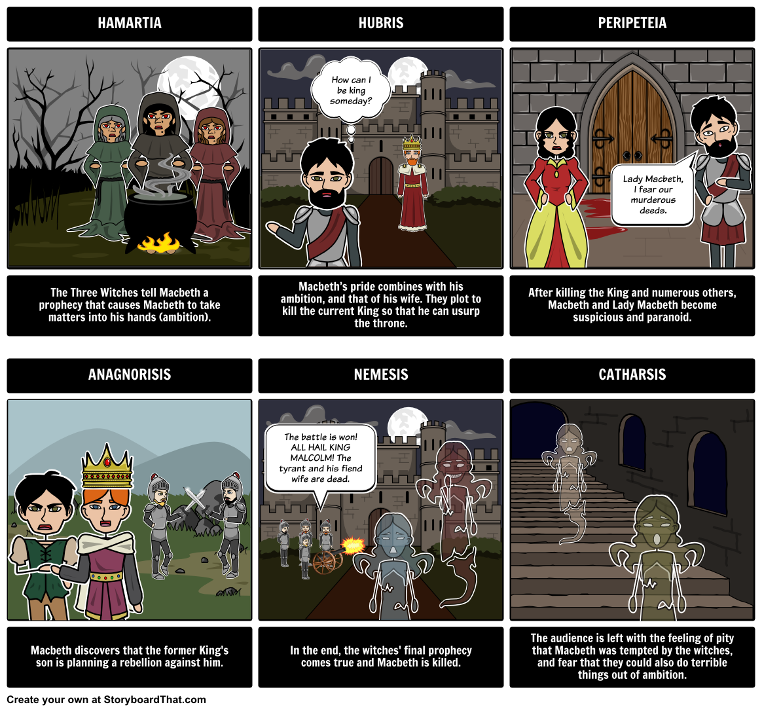
Use the following website to create it: https://www.storyboardthat.com/

