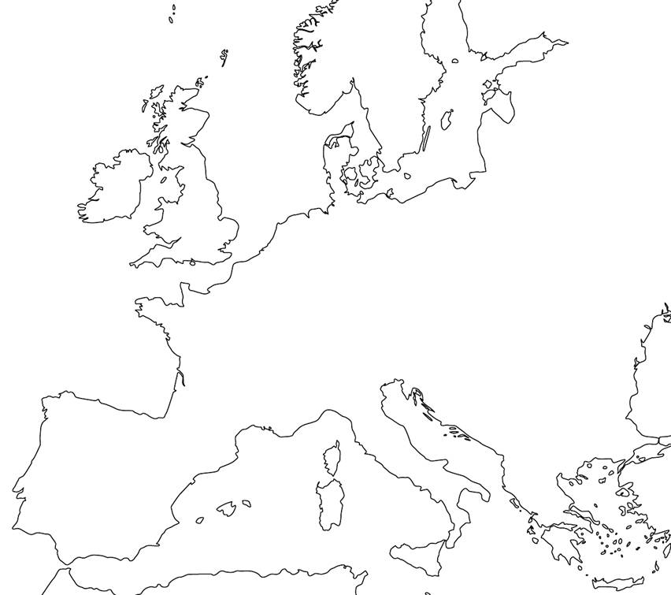

Absolutism Timeline
For your step two assignment, you will have to go beyond the information, create, analyze and draw conclusions from a map of Europe during the time of Absolutism. Through the map, you will be able to identify the political outcomes of absolutism and its effect on Europe.
Directions: Use pages 153, 156, 170,176 and 182 (in addition to any and all other resources) to label and Identify the following areas:
Cities: Regions (Color these regions 2 pt each) Water (10 Points)
Paris Spain Mediterranean Sea
Madrid England Atlantic Ocean
Danzig France North Sea
Moscow Austria
London Russia
Vienna Prussia
Identify the following
The areas that were central to the Seven Years War (Color and label) 3 points
Mark the movement movement of the Hapsburgs throughout Europe (5 points)

Neatness and clarity make up 2 points _________/20 pts
Below, write a summary of Central European monarchies, their POLITICAL struggles amongst one another and HOW those struggles impact their rule. (5 pts)

